**Assignment (20%)**

* This is a group assignment. You can have 3 - 4 students in a group.
* All members of the group **MUST** be from the same tutorial session.
* One of the group members must be assigned as a leader to manage the work and evaluate each member.
* The due date for the assignment is on 10 .02. 2020, latest by 11:30 am.
* You MUST submit your assignment in **hardcopy** and **softcopy** (CD or USB).
* For this assignment you MUST use Java or VB only, **NO** HTML or PHP is allowed.
* For this assignment **YOU** **MUST HAVE A GRAPHICAL USER INTERFACE GUI** and easy to use.

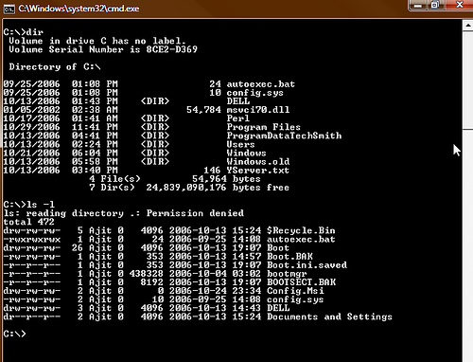

**NOT ALLOWED**

**Implement ONE application with two modules (Parts)**

**Part 1**

Program that can convert NFA into DFA and Minimizes the resulting DFA.

NOTE: NFAs can be entered in form of graphics (preferable) or transition table.

Example1 : by transition table

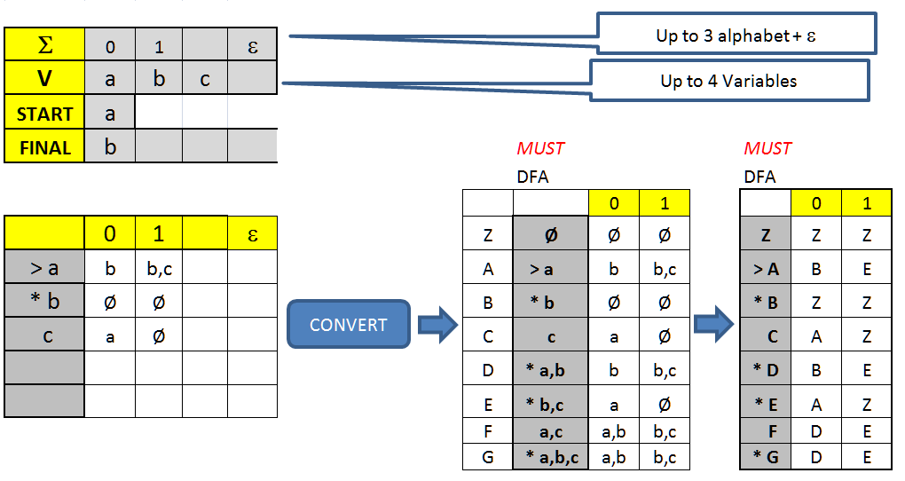

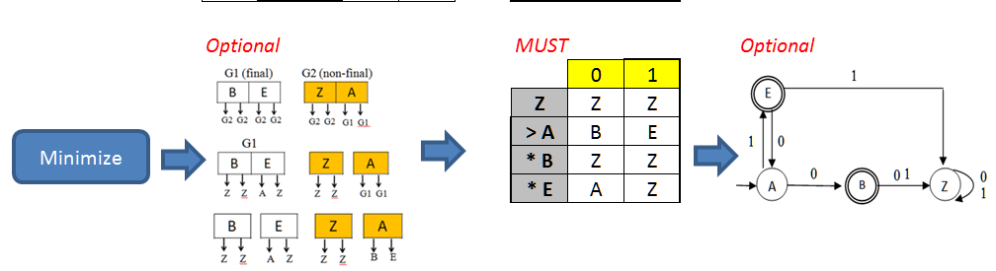

Example2 : NFA in form of graphics (preferable), 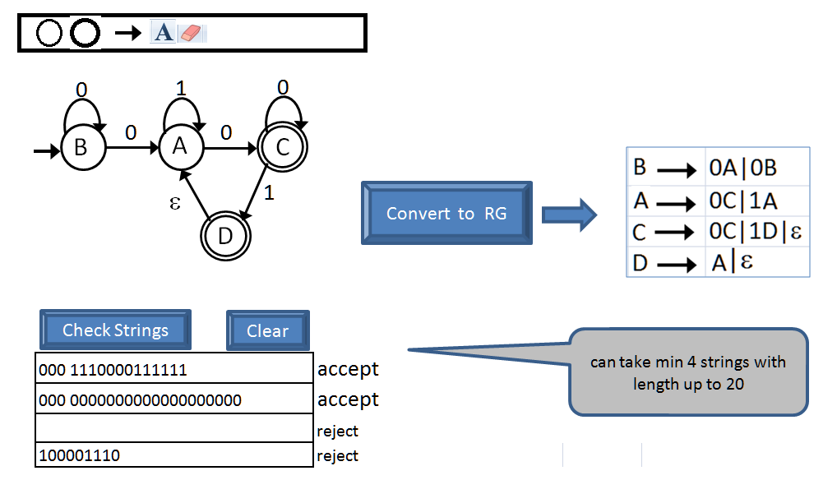

**Part 2**

Write a program that can do the following:

Phase 1) converts context-free grammar into Chomsky normal form (CNF).

* 1. **Input:** Context-free grammar,
  2. **Output:** Grammar in Chomsky normal form (CNF) (show the steps)

Phase 2) generates the CYK based on the CNF grammar that was produced in Phase (1)

**Input:** String to be parsed

1. **Output**: The program should show the following output
   1. Display of the CYK chart (Table)
   2. A statement to inform user whether the string can/cannot be generated by the grammar

**Important: Final App must look like the example below : ONE application with home screen and other modules (Parts) with one .exe file. POP-UPS SCREENS AND MESSAGES ARE NOT ALLOWED**

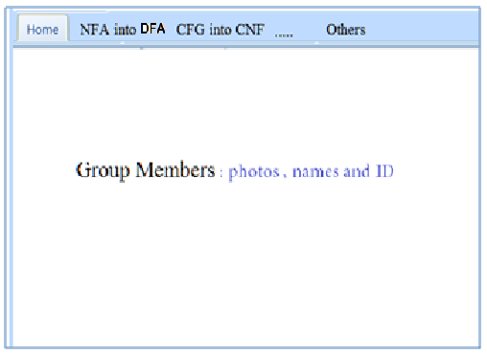

**Documents must include:**

1. Cover page
2. Members and their participation percentages
3. Introduction
4. Design Flowcharts , DFA, NFA
5. 4 screenshots
6. Manual with examples
7. Important codes